As a student at Union College, I am part of a community that values intellectual effort, curiosity and discovery. I understand that in order to truly claim my educational and academic achievements, I am obligated to act with academic integrity. Therefore, I affirm that I carried out the work on this exam with full academic honesty, and I rely on my fellow students to do the same.

For this Exam, I understand that:

1. I **must** work alone in writing out the solutions to the problems in this exam.
2. I **cannot** copy solutions, in part or whole, to the problem on this exam from any person or resource.
3. I **cannot** use any electronic resources to assist me in the solution to the questions on this exam except for the Excel, MatLab, or other computer programs that I developed in this course and my calculator to only performing appropriate calculations on the exam. Excel and MatLab have to be started such that no solutions or algorithms have been preprogramed by me.
4. Because I am being allowed to use my own computer to solve problems on this exam, I **can** only have the program that I developed as part of this course running on my computer during the exam. I **cannot** have any other programs running during the exam, this is meant to include email, web browsers, etc.
5. I **can** use one page - single sided - of notes during the exam. This one page of notes **cannot** contain any solutions to problems. **I must staple this page to the back of my exam at the end of the exam**.

Signature:

Print Name:

Exam Date:

**PROBLEM 1:**At a point in a loaded member, the stresses relative to a x-y-z coordinate system are given by:



**1a.** Draw the state of stress on the cube shown.

**1b.** Determine the principal stresses for this state of stress and their directions cosines. (If you use MATLAB or Excel to perform calculations, be sure to print out the Command Window or spreadsheet that contains the commands you used to perform the calculations AND ATTACH THE PRINT OUT DIRECTLY BEHIND THIS PAGE OF THE EXAM.)

**1c.** Write the transformation matrix that will transform the original state of stress to the principal state of stress.

**1d.** What angles (in degrees) do each of the principal stresses make with the x, y, and z axes?

σ1: θ1x= θ1y= θ1z=

σ2: θ2x= θ2y= θ2z=

σ3: θ3x= θ3y= θ3z=

**1e.** Draw the principal state of stress on the stress cube provided. Make sure to use the engineering convention that σ1>σ2>σ3.

**1e.** Draw Mohr’s circle for the 3 dimensional state of stress at this point.

**1f.** What is the absolute maximum shear stress and the normal stresses that accompany it? Illustrate the state of stress where the shear stress is maximum on the cube below where the x”y”z” coordinate system is orientated such that it shows the maximum shear stress when one of the faces is in the principal state of stress.

**1g.** What angles does the cube above make the original x, y, and z coordinates (if an algorithm is being used, attach it directly behind this page).

θx”x= θx”y= θx”z=

θy”x= θy”y= θy”z=

θz”x= θz”y= θz”z=

**PROBLEM 2:** The structure below is loaded as shown. At the EFGHC cross-section the internal loads caused by this loading condition are shown in an expanded view below the figure.

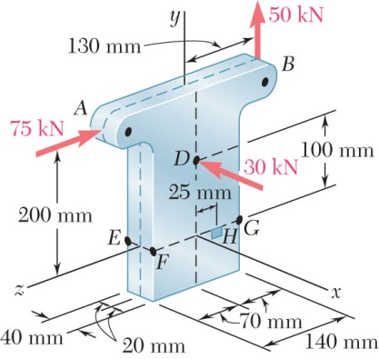

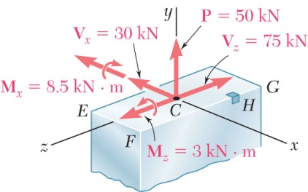

**2a.** Determine the complete state of stress at point H in the structure (for a rectangle I=(1/12)* b*h3).

**2b.** Draw the complete state of stress at H on the cube below.